Vectors – Teaching Set 2

1. polar rectangular.
In this problem, you’ll derive equations to find the <x, y> components of a polar vector. This is super useful in a lot of contexts! It’s something you’ll use over and over again for several units.

a. Say I have a vector $1∠\frac{π}{6}$ (distance 1, angle $\frac{π}{6}$ which is $30°$).
What’s that vector in rectangular form <______, _____> ?

I intentionally didn’t give you any hints here, but check the next page if you’re not sure how to start thinking about this.

b. Convert $5∠\frac{π}{6}$ to rectangular form. (what simple thing could you do to your answer from (a)? ).
$$θ$$
r
c. Generalize. What if the distance is r and the angle is $θ$?
Write it as a useful equation: $r∠θ=$ < ______ , ______ > where each blank is an equation with r and $θ$ in it.

d. Let’s think about your equation in a slightly different way

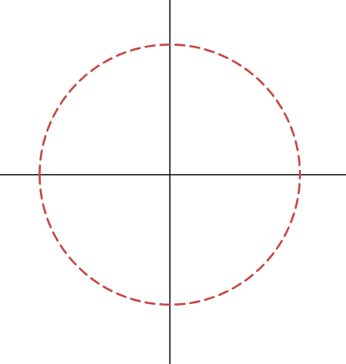
Think:
$$θ$$
$$r$$
$$1$$
$$r$$
$$-1$$
$$-r$$
$\cos\left(angle\right)$ tells you the x-coordinate on the unit circle

$\sin\left(angle\right)$ tells you the y-coordinate on the unit circle

How do you see your equation in the diagram to the right?
(not sure? Get the next set of problems and we’ll debrief this part)

2. Unit vectors
In this problem you discover how to scale a vector down until it’s length 1. That’s what a unit vector is! They’re also useful for a lot of things.
If I have a vector $\overset{⃑}{v}$, its unit vector is a vector that points in the same direction as $\overset{⃑}{v}$ but has a lenth of 1.
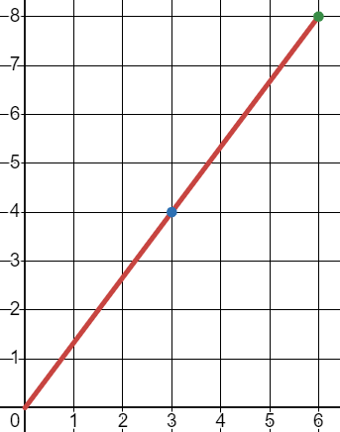
What can you scale a vector by to make it length 1?
$$\vec{a}$$
Let’s find out...
Let $\overset{⃑}{a}=<6, 8>$ $\left|\left|\vec{a}\right|\right|=$ ________________________
a). What happens if you scale the vector in half?
Let $\frac{\overset{⃑}{a}}{2}= <______, _______>$ $\left|\left|\frac{\vec{a}}{2}\right|\right|=$ _________________________
b). What if you scale the vector to be 1/10th its original size?
Let $\frac{\overset{⃑}{a}}{10}= <______, _______>$ $\left|\left|\frac{\vec{a}}{10}\right|\right|=$ _________________________
c). Why did scaling by 1/10th result in a length 1 vector? What was special about 1/10th ?
Make a general theory. If you had another vector, how would you know how much to scale it by to make it length 1?
d). Illustrate your idea: Let $\vec{b}=<5, 12>$. Find the scale-factor that will turn $\vec{b}$ into a unit vector. Show that it does so.

3. Make a vector any length
Let $\vec{c}=<1, 5>$. What if I want a vector pointed in the same direction a $\overset{⃑}{c}$ but with a length of 2.
Here’s a 2-step strategy: scale it to be length 1, and then double its length.
a). Find the vector that’s pointed the same as $\overset{⃑}{c}$ but that has length 2
b). Find the vector that’s pointed the same as $\overset{⃑}{d}=<2, 2>$ but with length 7.

HINTS:
1a. Two good problem solving tools you could use here are:
$$\frac{π}{6}$$
1
- Draw a picture
- Label what you want to know using math notation
So. I’ve drawn a picture for you. You want to know the x and y components. Where would they go in the picture. Does that give you any ideas?

Vectors – Teaching Set 2 – Solutions

1. polar rectangular.
a. Say I have a vector $1∠\frac{π}{6}$ (distance 1, angle $\frac{π}{6}$ which is $30°$).
$$\frac{π}{6}$$
1
What’s that vector in rectangular form <______, _____> ?

If I think using SOH-CAH-TOA, I can see that $\cos\left(\frac{π}{6}\right)=\frac{x}{1}$ and $\sin\left(\frac{π}{6}\right)=\frac{y}{1}$. But that’s just saying that $x=\cos\left(\frac{π}{6}\right)$ and $y=\sin\left(\frac{π}{6}\right)$. You know those values: $x=\frac{\sqrt{3}}{2}$ and $y=\frac{1}{2}$. So: $1 ∠ \frac{π}{6}= <\frac{\sqrt{3}}{2},\frac{1}{2}>$

b. Convert $5∠\frac{π}{6}$ to rectangular form.
$$\frac{π}{6}$$
5
$$θ$$
r
Here the hypotenuse is just length 5. Using SOH-CAH-TOA again:
$\cos\left(\frac{π}{6}\right)=\frac{x}{5}$ $x=5⋅\cos\left(\frac{π}{6}\right)=\frac{5\sqrt{3}}{2}$
$\sin\left(\frac{π}{6}\right)=\frac{y}{5}$ $y=5⋅\sin\left(\frac{π}{6}\right)=\frac{5}{2}$
So: $5 ∠ \frac{π}{6}= <\frac{5\sqrt{3}}{2},\frac{5}{2}>$ (which, notice, is the same thing as $5⋅<\frac{\sqrt{3}}{2},\frac{1}{2}>$

c. Generalize. What if the distance is r and the angle is $θ$? In general, we can derive the equations with variables instead of numbers in the exact same way.
$$θ$$
r
$\cos\left(θ\right)=\frac{x}{r}$ $x=r⋅\cos\left(θ\right)$
$\sin\left(θ\right)=\frac{y}{r}$ $y=r⋅\sin\left(θ\right)$
So: $r ∠ θ= <r⋅\cos\left(θ\right),r⋅\sin\left(θ\right)>$ (which, again, is the same thing as $r<\cos\left(θ\right),\sin\left(θ\right)>$. This interpretation is what the next problem is about ).

d. Let’s think about your equation in a slightly different way
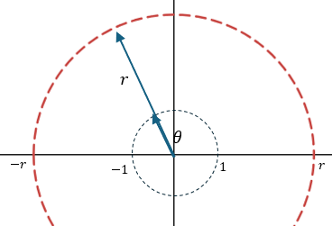
$\cos\left(angle\right)$ tells you the x-coordinate on the unit circle
$\sin\left(angle\right)$ tells you the y-coordinate on the unit circle

You know $1 ∠ θ$ is $<\cos\left(θ\right), \sin\left(θ\right)>$. It describes the point on the unit circle at an angle of $θ$. What if we scale the vector by length r ? It’s pointed in the same direction (ie same angle $θ$), but not it describes the (x, y) coordinates on a circle radius r. Scaling it gives: $r<\cos\left(θ\right),\sin\left(θ\right)>$, but that’s exactly the same as your solution from the previous part. So the point is: you can think about it using SOH-CAH-TOA, or you can think about it as a point on the unit circle which you scale to be the size you want.
2. Unit vectors

If I have a vector $\overset{⃑}{v}$, its unit vector is a vector that points in the same direction as $\overset{⃑}{v}$ but has a lenth of 1.
$$\vec{a}$$
What can you scale a vector by to make it length 1?
Let’s find out...
Let $\overset{⃑}{a}=<6, 8>$ $\left|\left|\vec{a}\right|\right|=\sqrt{6^{2}+8^{2}}=\sqrt{100}=10$
a). What happens if you scale the vector in half?
Let $\frac{\overset{⃑}{a}}{2}= <3, 4>$ $\left|\left|\frac{\vec{a}}{2}\right|\right|=\sqrt{3^{2}+4^{2}}=\sqrt{25}=5$
The coordinates are each half as big. The length of the vector (which is just the lenth of the hypotenuse) is also half as long.
This makes sense. Imagine the vector as the entire right triangle. If you scale two sides to be half as long, the third side scales as well. So, really, you’re just scaling the whole triangle.
b). What if you scale the vector to be 1/10th its original size?
Let $\frac{\overset{⃑}{a}}{10}= <\frac{6}{10},\frac{8}{10}>$ $\left|\left|\frac{\vec{a}}{10}\right|\right|=$ $\sqrt{{\left(\frac{6}{10}\right)}^{2}+{\left(\frac{8}{10}\right)}^{2}}=\sqrt{\frac{100}{100}}=1$
c). Why did scaling by 1/10th result in a length 1 vector? What was special about 1/10th ?
Since the original vector was length 10, all we did was divide it by its own length to get a length of 1, which hopefully makes good intuitive sense.
d). Illustrate your idea: Let $\vec{b}=<5, 12>$. Find the scale-factor that will turn $\vec{b}$ into a unit vector. Show that it does so.
Here $\left|\left|\vec{b}\right|\right|=\sqrt{25+144}=\sqrt{169}=13$. So if we scale it by $\frac{1}{13}$ it will be unit length.
$\frac{1}{13}<5, 12> = <\frac{5}{13}, \frac{12}{13}>$. $\left|\left| <\frac{5}{13}, \frac{12}{13}>\right|\right|=\sqrt{{\left(\frac{5}{13}\right)}^{2}+{\left(\frac{12}{13}\right)}^{2}}=\sqrt{\frac{169}{169}}=1$

3. Make a vector any length
Let $\vec{c}=<1, 5>$. What if I want a vector pointed in the same direction a $\overset{⃑}{c}$ but with a length of 2.
Here’s a 2-step strategy: scale it to be length 1, and then double its length.
a). Find the vector that’s pointed the same as $\overset{⃑}{c}$ but that has length 2
First let’s scale it to a unit vector: $\left|\left|\vec{c}\right|\right|=\sqrt{26}$. So $\frac{1}{\sqrt{26}}<1, 5>$ is the unit vector of $\vec{c}$. Now we’ll scale it to be length 2: $\frac{2}{\sqrt{26}}<1, 5>$. Done! You could write it that way, or as $<\frac{2}{\sqrt{26}},\frac{10}{\sqrt{26}}>$ since those are the same.
b). Find the vector that’s pointed the same as $\overset{⃑}{d}=<2, 2>$ but with length 7. $\left|\left|\vec{d}\right|\right|=\sqrt{8}=2\sqrt{2}$. So a length 7 vector in the same direction would be $\frac{7}{2\sqrt{2}}<2,2> =\frac{7}{\sqrt{2}}<1,1>$

